
Session 8H/M220, Friday 11 July, 15:30-16:30, Level 2, Room 220 Special Interest Group on Social Work with Groups: Joining Together from 2004-2014
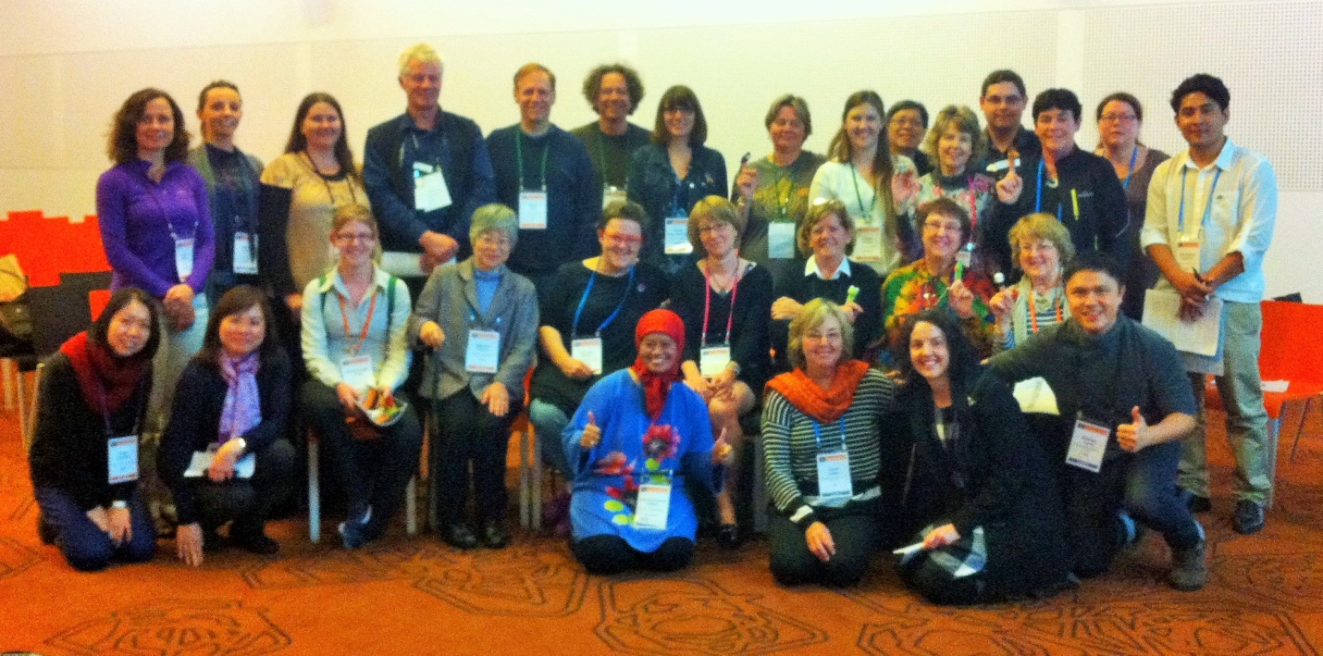
Figure 1 Group Photo of the 2014 Melbourne Special Interest Group on Groupwork - Apologies to those who had to leave early
Convened by Carol S. Cohen (United States), Sharima Ruwaida Abbas (Malaysia), and Carol Irizarry (Australia), over 30 Joint World Conference attendees participated in a Special Interest Group on Groupwork in Melbourne, Australia. The areas identified as their home countries were: Australia, Austria, Canada/Quebec, China, Hong Kong, Indonesia, Italy, Japan, Malaysia, Nepal, New Zealand, South Africa, United Kingdom, United States, and Vietnam.
Access the Special Interest Group PowerPoint
Session Summary by Carol Irizarry, Followed by More Photos by Sharima Ruwaida Abbas
1) Background to the formation of this Special Interest Group
The session began with an acknowledgment of the consistent energy and effort that Carol Cohen had contributed to arranging a Special Interest Group at the social work international conferences over the past decade. She was thanked by the group members. (I am so grateful for these kind words and fantastic collaborators! -- Carol)
Carol gave a brief background of the formation of a Special Interest group over the years and the increasing participation in the sessions. The goal of organizing these sessions was to strengthen and sustain the connections of social workers from around the world who were using groups as part of their practice or whose interest was focused on social work with groups. Carol showed pictures of the groups that had been convened at previous conferences.
2) Introductions – Group Work Practice
Members of the group introduced themselves and spoke about their particular connection to group work and their motivation for coming to this session. Many group work programs were identified as central to the practice of those who attended. Following are the kinds of groups or populations that those who were present identified as there are of work:

- children’s groups
- disaster groups
- inpatient rehab and community rehab recovery
- domestic violence
- disability
- sexual abuse
- suicide survivors
- mental illness, child mental health & community mental health
- relocation groups
- university student groups
- therapeutic theatre groups,
- psychodynamic groups
- committee groups
- groups in private practice
- school groups,
- single mothers groups
- mothers with mental health issues,
- indigenous group work
- hospital in-patient groups

Each person gave a short more detailed description of his or her practice in the above area.
In addition to those who were involved in convening groups as part of their direct social work practice, there were others who introduced themselves and talked about their interest in and involvement with groups in a non-client capacity. These areas were identified as:

- teaching
- research
- supervision
- political groups
- feminist
- journal of group work,
- change management and change groups
- self-directed research on group work

There was quite a variety among those who attended this session in their use of group work but the common thread was a recognition of the value of groups in social work and a commitment to continuing learning from others about group work in contexts different from their own. As members talked they identified common themes but also the impact of their own cultural or political context on their work.
Greg Tully, President of the International Association for Social Work with Groups (IASWG) encouraged everyone to check out the site at: www.iaswg.org, and consider participating in the international association, including the annual symposia. The Symposium was in Calgary, Canada this past June, and will be in North Carolina, US in June, 2015.
3) Common Themes
Emerging from the introductions and subsequent discussions were several common themes which members agreed were of importance to fostering a high standard of practice with groups. These themes were:
- Courses on Social work with Groups need to be included in social work curriculum across the world. This teaching should include all levels of assessment, intervention and evaluation.
- Continued training is important for those working with groups in the field
- Assessment of skills in working with groups needs to be constantly revisited and developed
- Assessment by observing “actual” groups work practice is important including reflection on the work

4) Research
There was discussion and exchange of ideas around research by those who regarded social group work as central to their interests. A few of the projects on interest and/or being undertaken were:
- The use of group supervision in fieldwork
- Best practice in supervision of group work students
- Peer supervision (in New Zealand)
- Evaluation studies of effectiveness of group practice
- Use of groups in the classroom
- Contribution of group learning in social work group supervision

We discussed the possibility of small groups of groupworkers applying for IASSW Grants, to work on one or more of these research areas. Information on this grant program is available at: http://www.iassw-aiets.org/project-funding. Grants are for up to $4,000.00 (US), and it must be an international proposal, with at least 3 social work education programs from at least 2 countries. People interested in this possibility can contact attendees directly.
5) Communication
Most of the time together was spent in discussion and sharing ideas and suggestions around the subjects listed above. To foster and encourage continued exchanges it was decided to open a Facebook site so that those who attended could keep in touch with each other if they wished and post relevant information about themselves, their work or material related to group work. Research projects and information about articles could also be posted.
Anyone who would like their groupwork-related materials (including presentations, papers, photos, and queries) posted on the Global Group Work Project site at www.globalgroupworkproject.com can send them to Carol Cohen at cohen5@adelphi.edu.

Photos of Our Special Interest Group Session: July, 2014 Melbourne, Australia
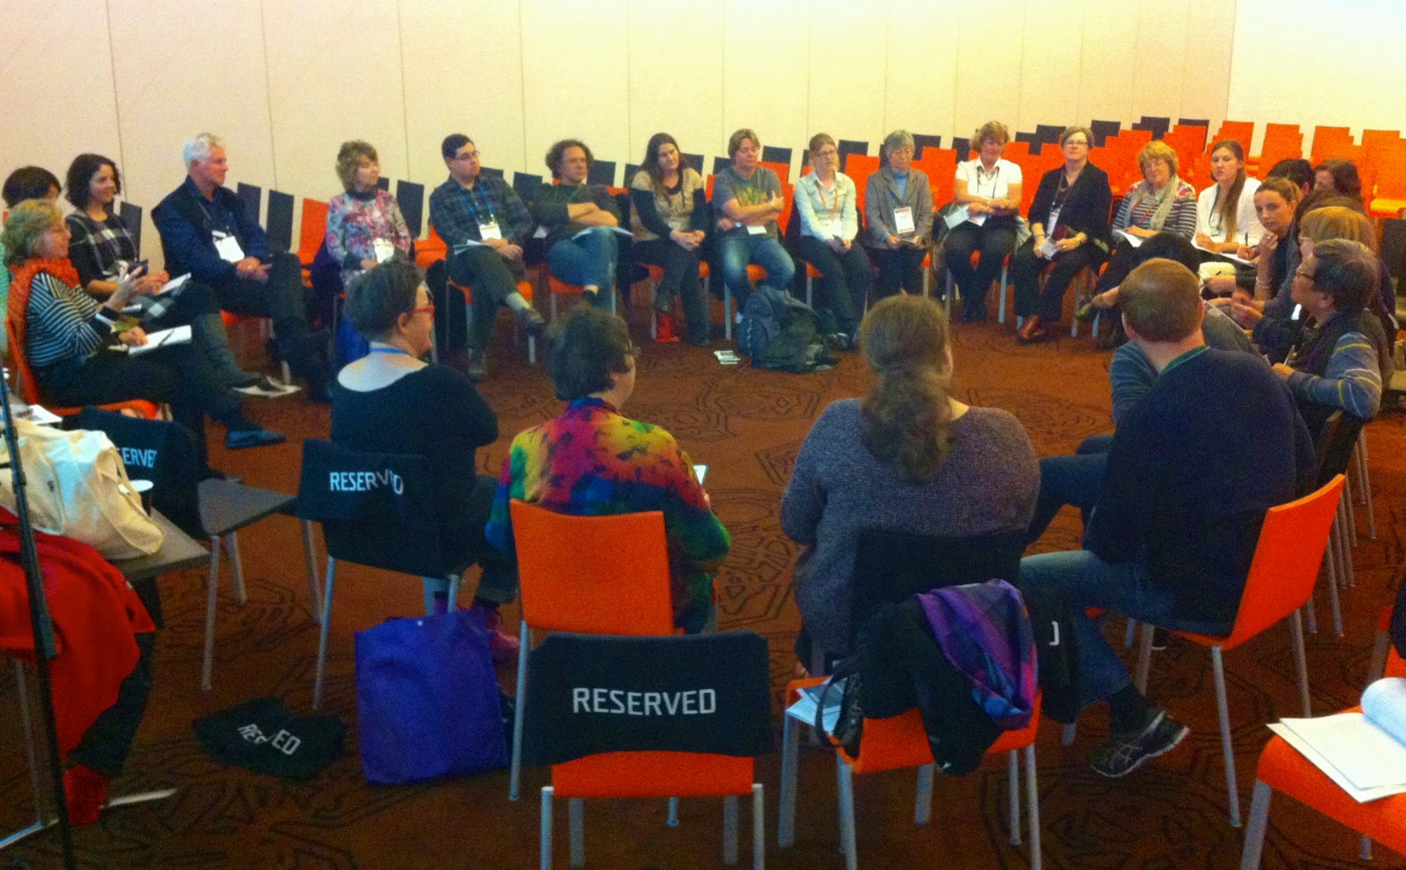
Figure 2 Photos around the circle at the Special Interest Group on Groupwork, Melbourne, Australia